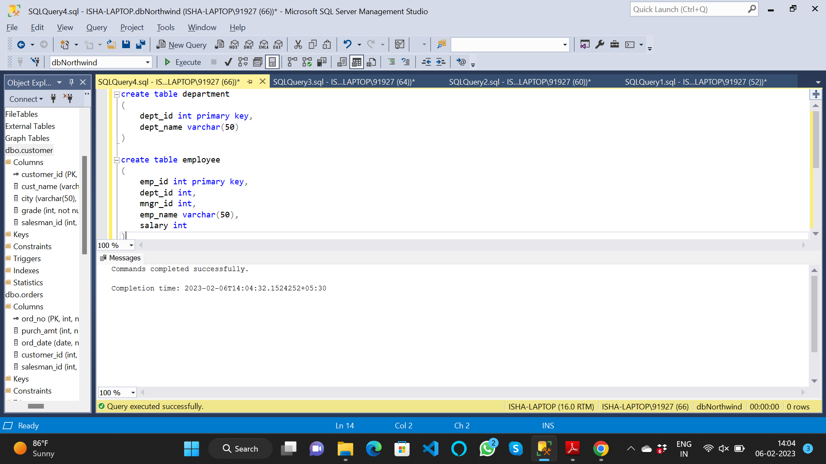

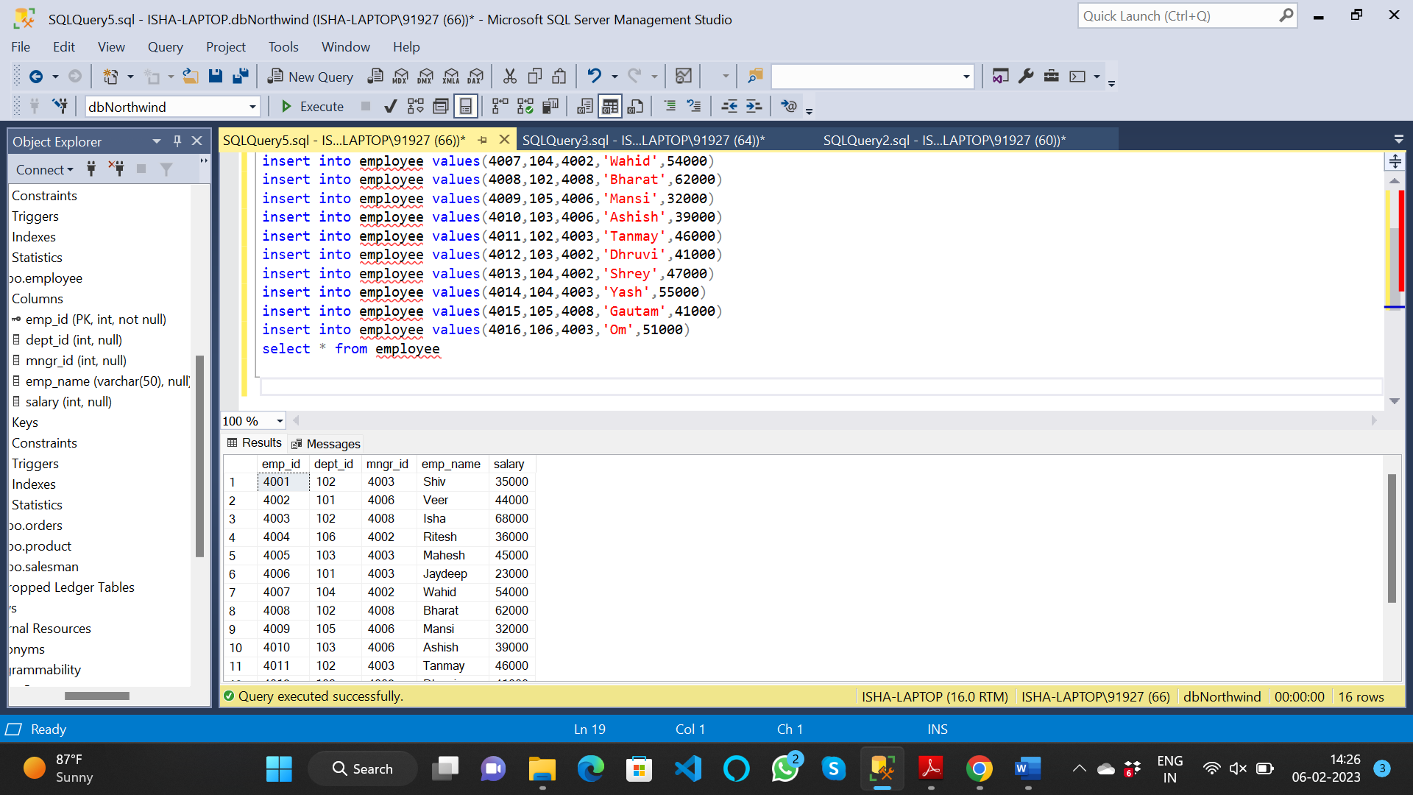

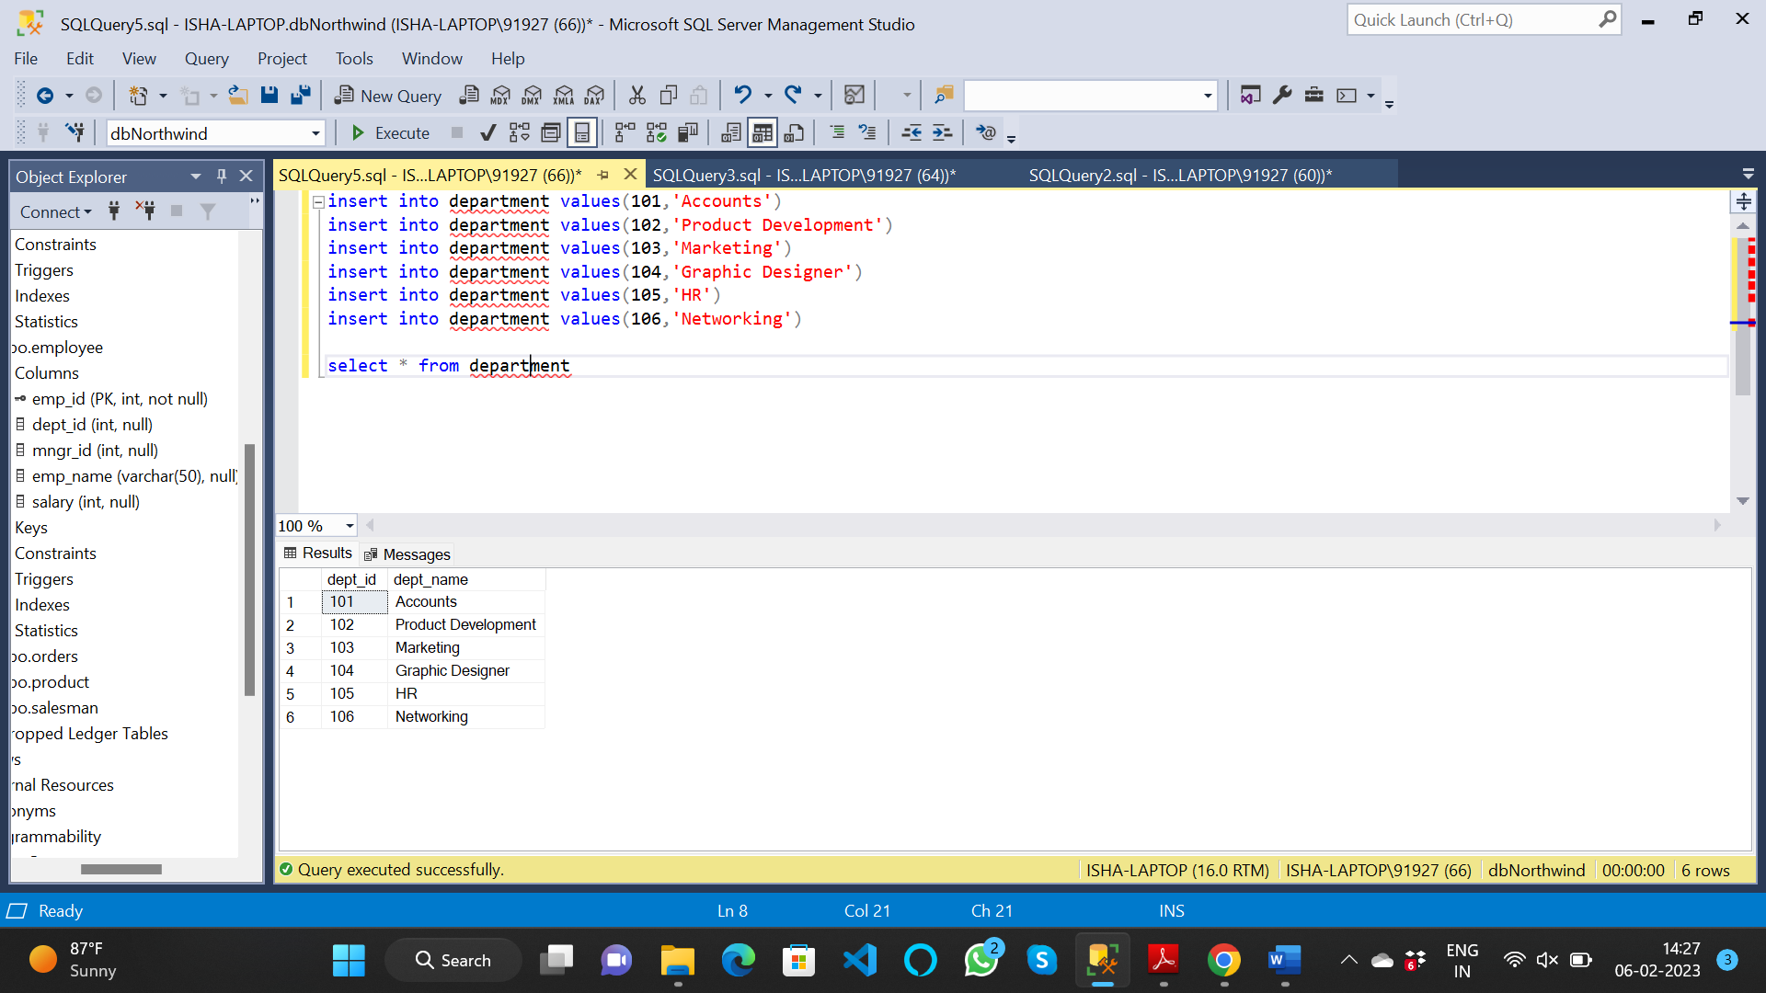

1. write a SQL query to find Employees who have the biggest salary in their Department

with w1 as (

select rank() over (partition by dept_id order by Salary desc) rank,

dept_id,

emp_name,

Salary

from Employee)

select d.dept_name as "Department",

w1.emp_name as "Employee",

w1.SALARY as "Salary"

from w1

join Department d

on d.dept_id = w1.dept_id and RANK = 1

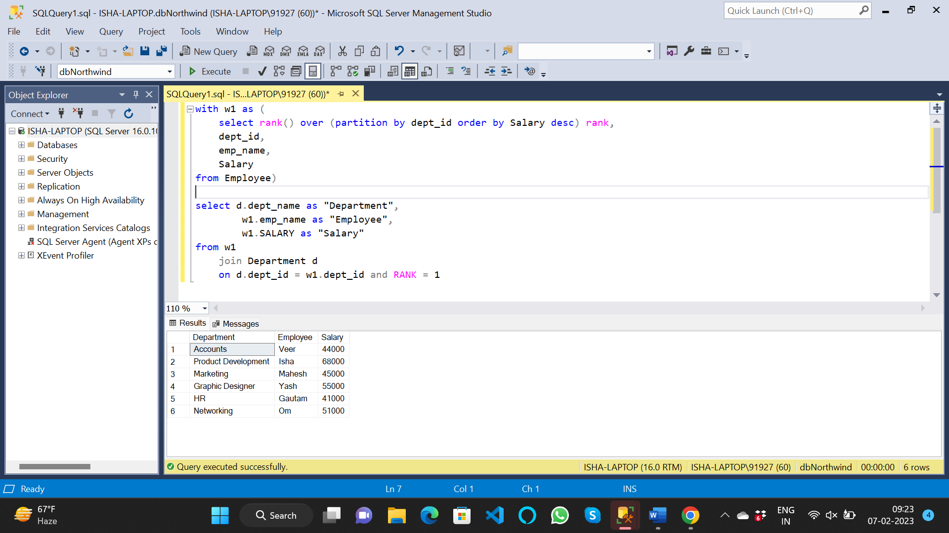

2. write a SQL query to find Departments that have less than 3 people in it

select dept_id,dept_name

from department

where dept_id in (select e.dept_id from employee e group by dept_id having count(*)<3)

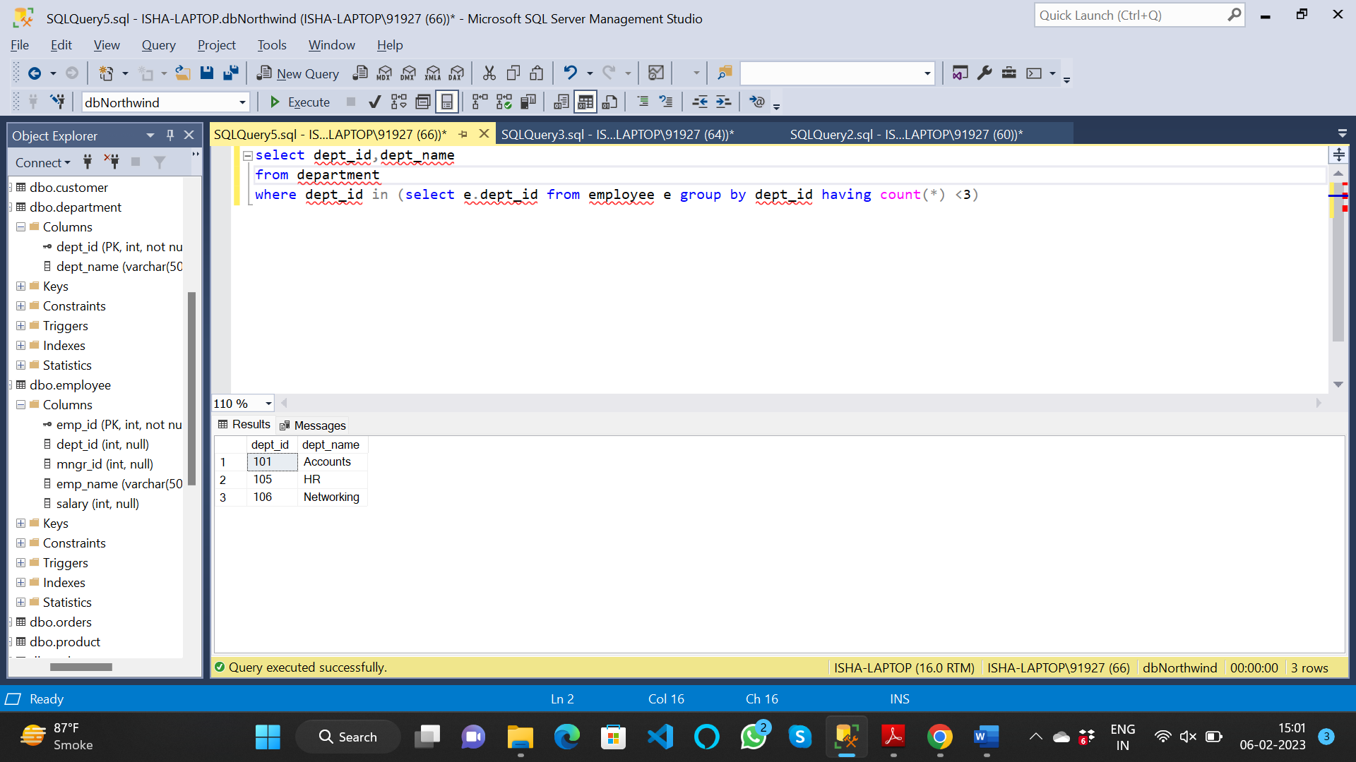

3. write a SQL query to find All Department along with the number of people there

select d.dept_name, count(*) as [no. of employee]

from employee e join department d

on d.dept_id=e.dept_id

group by d.dept_name

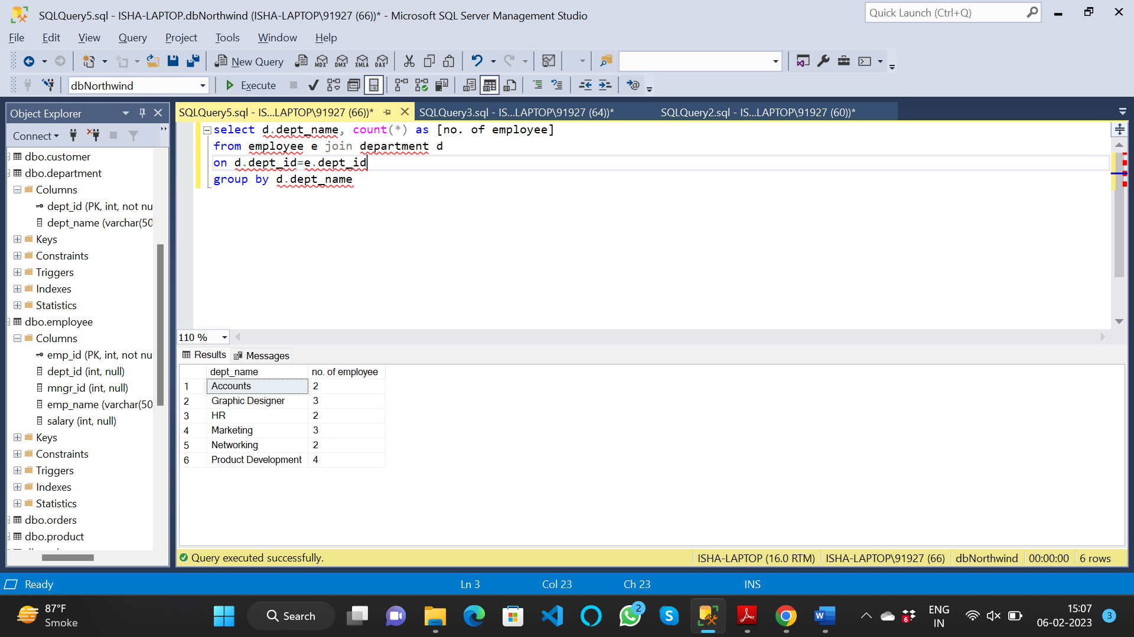

4. write a SQL query to find All Department along with the total salary there

select d.dept_name, sum(e.salary) as [no. of employee]

from employee e join department d

on d.dept_id=e.dept_id

group by d.dept_name

